Tiffany Chan
Maternal Anxiety Levels of Pediatric Bone Marrow Transplant Patients
Introduction:
The goal is to model anxiety over time in mothers of pediatric patients that had undergone bone marrow transplantation, using mixed effects models. The data was collected in an observational study that measured anxiety levels at 3 different time points (which could also be referred to as baseline, time point 1 and time point 2). Without doing any sort of regression, it can be observed that all observations are layered on top of each other and that not much difference can be observed between mother participants. In order to describe the data’s statistical nature better, mixed models is a convenient method that summarizes the data’s overall distribution across time, and between mothers.
Software Program:
All analyses in this report will be done in R.
Description of Data Prior to Regression:
Anxiety variable: The anxiety variable is the dependent variable in this study and it is part of the fixed effects portion of this multilevel analysis. For this study, it is left as a continuous variable. In showing the frequency of anxiety scores, most mothers had very low anxiety scores, and the frequency histogram shows a steady normal distribution and a tail to the right (Figure 1).
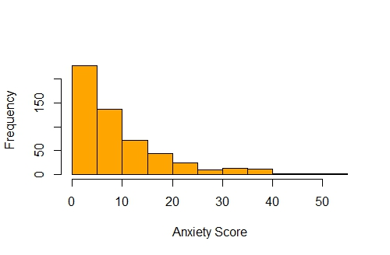
Figure 1. Histogram of Anxiety Scores of Mothers
in this Study.
ID variable: ID is considered a random variable and part of the random effect portion of the model because the number of participants can vary. ID is categorized in this analysis in order to differentiate one individual from another. In this study there were 216 mothers that participated.
Time variable: The time variable is an independent variable and it is a fixed variable because the observational study only looked at anxiety levels at these 3 specific times. However, when observing significant differences between women in their trajectories of change over time, the time variable had to be in a continuous form to generate interpretable output.
Malignancy variable: This denotes whether the mothers’ children were diagnosed with cancer. This is a fixed binary variable and could potentially explain individual differences in initial anxiety status and differences among mothers in their trajectories of change in anxiety (Figure 2).
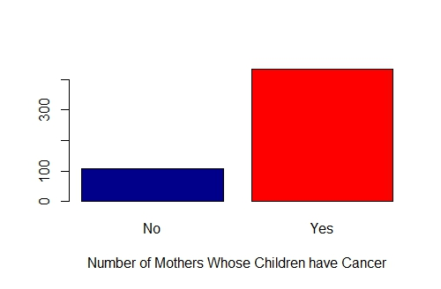
Figure 2. Frequency Barplot of Women Whose
Children are Diagnosed with Cancer.
Anxiety, Time, ID:
When looking at the different time points, the average of anxiety levels among mothers is the greatest at baseline at 11.212 and it decreases for the second time point and the third time point, to 8.322 and 8.021 respectively (Table 1). When averaging all the anxiety levels for all 3 time points for all participants, the average is 9.437.
Table 1. Average Anxiety Levels of Mothers with Bone Marrow Transplant Children at 3 Different Time Points and the Average of All Participants Across the Study.
 | Baseline | First Day | Second Day | Patient Averages
Time Average | 11.212 | 8.322 | 8.021 | 9.437
Of course, this is not the best method that describes the data because the variation between each participant is not visible. Barplots are also not the ideal method to display the data because it does not account for individual differences and it is difficult to know which individual is which (Figure 3).
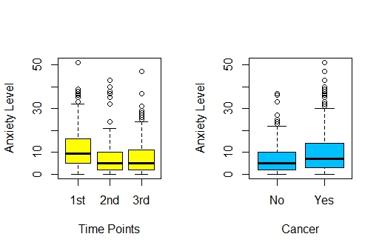
Figure 3. Useless Boxplots that Do Not Really Show Individual
Variability.
Technically, a spaghetti plot is better than the barplot and just calculating the averages of anxiety scores at each of the different time points and patient averages because we can make sense of the trend each individual displays for each time point. If we were to create a spaghetti plot, the variation between mothers can be observed, however, the distinctions are not entirely clear, even when we assign a different color to each participant (Figure 4). This plot can discern the individuals who have high extreme anxiety levels across the three time points, but most individuals have lower anxiety levels for all three time points. The spaghetti plot is problematic for this second group of individuals because their results are layered on top of each other and differences between individuals are more difficult to decipher.
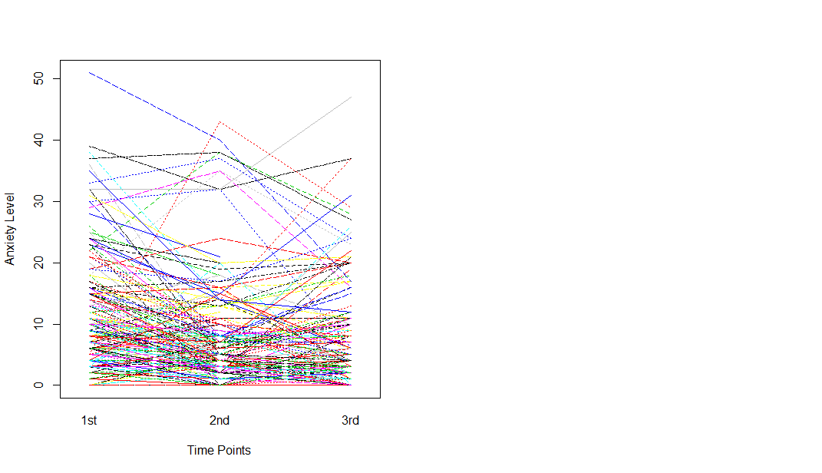
Figure 4. Somewhat Useless Colored Spaghetti Plot that Shows the Anxiety Levels of All Participants Across All 3 Time Points.
In order to better display and describe the results accounting for individual differences, mixed models were used to define the data and the interplay between the variables.
Results:
Fixed Slope, Random Intercept Model, Fixed Outcome: Anxiety, Fixed Effect: Time, Random Effect: ID.
In running the mixed model, individuals whose anxiety status were unknown or missing were taken out of the dataset. The intercept for the random effect (ID) along with the 95% confidence interval, and their residuals are displayed in the table below (Table 2).
Table 2. Mixed Model Regression, Fixed Model and Random Intercept, Given Time as an Independent Variable and ID as a Random Effect. Results for Random Effect: ID.
 | Estimate | 2.50% | 97.50% | Residual
Standard Deviation (intercept): | 6.75 | 5.961 | 7.644 | 5.729
2.50% and 97.50% are the 95% Confidence Intervals.
From the above table (Table 2), the intraclass correlation can be calculated with the estimate and residual using the formula: corr (anxiety_{i},_{j}, anxiety_{i},_{k}, anxiety_{i},_{l})= τ²₀₀/ (τ²₀₀ + σ²€), where j, k, l are all 3 time points in which anxiety status was determined across subjects i. The intraclass correlation (ICC) was calculated to be 0.58 and this value describes how strongly the mothers anxiety levels resemble each other. The intraclass correlation is only slightly closer to 1, meaning that individual level variability is only a little greater than group level variability. In this case, 0.58 is not too high and not too low, so there is some variability between mothers’ anxiety statuses.
Also, from Table 2, it can is observed that the intercept is positive, meaning that there is an increase in anxiety for individuals given the independent time variable included in the model. Since the intercept is nowhere near zero and the confidence intervals around the intercept estimate does not contain zero, this means that the difference between variances is statistically significant at the p < 0.05 level.
From the same mixed model regression, the following table shows the results for the time fixed effect (Table 3).
Table 3. Mixed Model Regression, Fixed Model and Random Intercept, Given Time as an Independent Variable and ID as a Random Effect. Results for Fixed Effect: Time.
 | Estimate (β) | 2.50% | 97.50%
Intercept | 11.694 | 10.509 | 12.879
Second Time Point | -3.545 | -4.702 | -2.388
Third Time Point | -3.468 | -4.806 | -2.33
2.50% and 97.50% are the 95% confidence Intervals.
Baseline or first time point is the reference category.

There is a significant effect of time on anxiety. Compared to the anxiety level measured at baseline, there is a 3.545 (95% CIs: -4.702, -2.388) decrease in anxiety score at the second time point and a further 3.468 (95% CIs: -4.806, -2.33) decrease in anxiety score at the third time point. Looking at the confidence intervals, 1 is not included, so both measures are statistically significant.
To know whether or not this data is in direct violation of the multilevel mixed effects regression assumption, it would be a good idea to display the QQ plot of the individual residuals to see whether there is a normal distribution for individual anxiety score means.
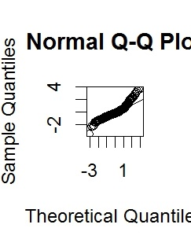
Figure 5. Q-Q Plot that Shows a Somewhat Normal Distribution of Individual Anxiety Score Means.
Figure 5’s Q-Q plot shows that the individual anxiety score means are somewhat normally distributed. Though the quantiles to the right show that the residuals are tapering off the QQ abline, the residuals for the most part stay pretty normally distributed. This shows that mixed effects regression model may be an appropriate means of describing the data.
Fixed Slope, Random Intercept Model, Fixed Outcome: Anxiety, Fixed Effects: Time, and Malignancy, Random Effect: ID.
To determine whether malignancy status explains differences among mothers in terms of initial anxiety status from the previous model, malignancy status should be included into the previous mixed effect regression model (Table 4). When the cancer status of the child was included into the model, the standard deviation of the intercept went down a little to 6.748 but after observing the lower and upper bounds of the 95% confidence intervals, the confidence interval does not contain0 and is still statistically significant, strongly suggesting that malignancy status has not much of an effect and more likely does not explain the differences among mothers in initial anxiety status.
At the same time, cancer status was not statistically significant as a fixed effect in the mixed model (Table 5), suggesting that there were no significant differences in anxiety status between those who had children diagnosed with cancer and those whose children were not diagnosed with cancer.
Table 4. Mixed Model Regression, Fixed Model and Random Intercept, Given Time and Malignancy Status as Independent Variables and ID as a Random Effect. Results for Random Effect: ID.
 | Estimate | 2.50% | 97.50% | Residual
Standard Deviation (intercept): | 6.748 | 5.947 | 7.657 | 5.698
2.50% and 97.50% are the 95% Confidence Intervals.

Table 5. Mixed Model Regression, Fixed Model and Random Intercept, Given Time and Malignancy Status as Independent Variables and ID as a Random Effect. Results for Fixed Effects: Time and Malignancy Status.
 | Estimate (β) | 2.50% | 97.50%
Intercept | 9.548 | 7.138 | 11.958
Second Time Point | -3.513 | -4.671 | -2.355
Third Time Point | -3.567 | -4.802 | -2.331
Cancer, Yes | 2.783 | 0.162 | 5.404
2.50% and 97.50% are the 95% confidence Intervals.
Baseline or first time point, and no cancer are the reference categories.
Random Slope, Random Intercept Model, Fixed Outcome: Anxiety, Fixed Effect: Time, Random Effect: ID with Time Varying on ID.
When we’re dealing with a random intercept and a random slope to describe the trajectories of change over time between individuals, the time variable must be continuous so that it can vary on each individual. If time is left as a categorical variable, no output is generated.
Table 6 shows the results when time is a continuous variable and is allowed to vary with each mother.
Table 6. Mixed Model Regression, Random Slope and Random Intercept, Given Time as an Independent Variable (Fixed Effect), and ID as a Random Effects with Time Varying on ID. Results for Random Effect: ID.
 | Estimate | 2.50% | 97.50%
Standard Deviation (Intercept): | 9.425 | 7.833 | 11.341
Standard Deviation (Time): | 2.792 | 1.973 | 3.952
2.50% and 97.50% are the 95% Confidence Intervals.
The standard deviation for the intercept for individuals is positive, showing that there is an increase in the trajectories of change in anxiety when time is allowed to vary with each participant. The 95% confidence intervals also do not include zero, meaning that there are significant differences between participants.
Random Slope, Random Intercept Model, Fixed Outcome: Anxiety, Fixed Effects: Time*Malignancy, Random Effect: ID with Time Varying on ID.
To see whether malignancy status can explain the differences among mothers in their trajectories of change in anxiety, an interaction term can be applied between the fixed effects of time and malignancy status. If the interaction term is significant, then malignancy status can account for differences among the individuals within this study. Tables 7 and 8 present these results.
Table 7. Mixed Model Regression, Random Slope and Random Intercept, Given Time, Malignancy Status, Time*Malignancy Status as Independent Variables (Fixed Effects), and ID as a Random Effects with Time Varying on ID. Results for Random Effect: ID.
 | Estimate | 2.50% | 97.50%
Standard Deviation (Intercept): | 9.46 | 7.861 | 11.385
Standard Deviation (Time): | 2.801 | 1.978 | 3.966
2.50% and 97.50% are the 95% Confidence Intervals.
There is not much difference once when we combine time and malignancy status into an interaction term between mothers. The standard deviation went up by a little bit and the 95% confidence intervals stay significant. This shows that cancer status or malignancy status does not really influence the differences between mothers in general. Table 8 results and the explanation below offer a plausible explanation.
Table 8. Mixed Model Regression, Random Slope and Random Intercept, Given Time, Malignancy Status, Time*Malignancy Status as Independent Variables (Fixed Effects), and ID as a Random Effects with Time Varying on ID. Results for Fixed Effects: Time and Malignancy Status.
 | Estimate | 2.50% | 97.50%
Intercept | 12.354 | 8.564 |  | 16.145
Time | -2.646 | -4.152 |  | -1.14
Cancer (Yes) | 1.156 | -3.099 |  | 5.412
Time*Cancer (Yes) | 0.85 | -0.839 |  | 2.54
2.50% and 97.50% are the 95% confidence Intervals.
No cancer or Cancer (No) is the reference category.
From this table, it is observed that the interaction term, time*cancer (yes) shows a decrease 0.85 decrease in anxiety score when time*cancer(no) is the reference category. However, this result is not statistically significant. Judging on cancer alone, the estimate is also not found to be statistically significant. Time, like the other preceding examples remain statistically significant. Because cancer itself is not statistically significant means that those who have children with cancer and those who have children without cancer are not significantly different in terms of anxiety. This is different from the result and explanation in Table 7 shown previously, which suggests that there is a difference between mothers individually, not mothers in groups stratified by the cancer status of their child. When we create a variable that combines those who submitted anxiety responses at all 3 time points and malignancy status, the women all appear to not be different in their anxiety scores, whether they have cancerous or non-cancerous children. Therefore, child malignancy status does not seem to explain the differences we see between subjects.
Discussion:
From the results, it can be said that malignancy status does not really provide the reason that explains these changes in anxiety scores between the individual mothers but there were significant differences in anxiety scores between mothers at baseline and in their trajectories of change over time. Sure, the estimates change a little when malignancy is introduced, but statistical significance and difference between individual mothers is mostly not based on the contribution of this variable because results were already statistically significant before malignancy status was factored into the model.
Performing a simple regression using a mixed model where time is either only a fixed effect or isalso allowed to vary on mothers, seems to shed light on the nature of this data. The addition of the random effects intercept calculation to the regular standard fixed effects regression allows us to understand variability between individuals without breaking the cardinal principle of epidemiology, which is studying the nature of an outcome at a population level, and avoiding measurements and comparisons at the individual level. Though this study looks at the variability between individuals, what is calculated is the mean of all individuals that describes the variability between one person and another.

Conclusion:
A mixed effects model is an efficient method that can better define multi-layered data. It was effective in determining whether significant differences in anxiety scores existed between individual mothers. Usually, a good method to see whether or not one should use a mixed effects model is to see whether the averages of each individual across the fixed effect is normally distributed by plotting these means on a histogram or a qq plot. In this case, though the residuals were not perfectly aligned with the qq line on the right in the qq plot, they nonetheless are pretty close to it, suggesting that the mixed effects model assumption of normal distribution may not be completely violated.

Syntax:
## Exploring the Anxiety variable at 3 different times.
> summary(moms.anxietywide$anxiety0)
Min. 1st Qu. Median Mean 3rd Qu. Max.
0.00 5.00 9.50 11.69 16.00 51.00
> summary(moms.anxietywide$anxiety1)
Min. 1st Qu. Median Mean 3rd Qu. Max. NA's
0.000 2.000 5.000 8.005 10.000 43.000 33
> summary(moms.anxietywide$anxiety2)
Min. 1st Qu. Median Mean 3rd Qu. Max. NA's
0.000 2.000 5.000 7.954 11.000 47.000 64
> summary(indanxietyaverages$anxiety)
Min. 1st Qu. Median Mean 3rd Qu. Max.
0.000 3.000 7.000 9.437 13.000 51.000

## Taking out the NAs for the anxiety variable in the wide dataset.
> widereset <- moms.anxietywide[complete.cases(moms.anxietywide[c("anxiety0","anxiety1","anxiety2")]),]
> summary(widereset)
id rmarital educ white
Min. : 1.0 Married :125 Min. : 2.000 Min. :0.0000
1st Qu.:301.2 Not Married: 19 1st Qu.: 6.000 1st Qu.:1.0000
Median :516.5 NA's : 2 Median : 7.000 Median :1.0000
Mean :495.9 Mean : 7.048 Mean :0.7808
3rd Qu.:740.8 3rd Qu.: 8.000 3rd Qu.:1.0000
Max. :928.0 Max. :10.000 Max. :1.0000

income bmtrisk disrisk abeartox
Min. :1.00 Min. :1.000 Min. :1.000 Min. : 0.000
1st Qu.:4.00 1st Qu.:2.000 1st Qu.:2.000 1st Qu.: 1.000
Median :6.00 Median :2.000 Median :3.000 Median : 2.000
Mean :6.24 Mean :1.993 Mean :2.486 Mean : 2.671
3rd Qu.:9.00 3rd Qu.:2.000 3rd Qu.:3.000 3rd Qu.: 3.750
Max. :9.00 Max. :3.000 Max. :4.000 Max. :10.000
NA's :2
aicu cancer time0 time1 time2
Min. :0.00000 Cancer :117 Min. :1 Min. :2 Min. :3
1st Qu.:0.00000 No cancer: 29 1st Qu.:1 1st Qu.:2 1st Qu.:3
Median :0.00000 Median :1 Median :2 Median :3
Mean :0.08904 Mean :1 Mean :2 Mean :3
3rd Qu.:0.00000 3rd Qu.:1 3rd Qu.:2 3rd Qu.:3
Max. :1.00000 Max. :1 Max. :2 Max. :3

fears0 fears1 fears2 anxiety0
Min. : 0.000 Min. : 0.000 Min. : 0.000 Min. : 0.00
1st Qu.: 3.000 1st Qu.: 3.000 1st Qu.: 3.000 1st Qu.: 4.00
Median : 4.000 Median : 4.000 Median : 4.000 Median : 9.00
Mean : 4.548 Mean : 4.848 Mean : 4.685 Mean :11.21
3rd Qu.: 6.000 3rd Qu.: 6.000 3rd Qu.: 6.000 3rd Qu.:15.00
Max. :12.000 Max. :12.000 Max. :12.000 Max. :51.00
NA's :1
anxiety1 anxiety2 depress0 depress1
Min. : 0.000 Min. : 0.000 Min. : 0.00 Min. : 0.000
1st Qu.: 2.000 1st Qu.: 2.000 1st Qu.: 6.00 1st Qu.: 4.000
Median : 5.000 Median : 5.000 Median : 9.00 Median : 7.000
Mean : 8.322 Mean : 8.021 Mean :10.25 Mean : 8.814
3rd Qu.:11.000 3rd Qu.:11.000 3rd Qu.:13.00 3rd Qu.:13.000
Max. :43.000 Max. :47.000 Max. :38.00 Max. :46.000
NA's :1
depress2 gvhd0 gvhd1 gvhd2
Min. : 0.000 Min. :0.0000 Min. :0.0000 Min. :0.0000
1st Qu.: 3.000 1st Qu.:0.0000 1st Qu.:0.0000 1st Qu.:0.0000
Median : 5.500 Median :0.0000 Median :0.0000 Median :0.0000
Mean : 7.938 Mean :0.1986 Mean :0.1644 Mean :0.1049
3rd Qu.:12.000 3rd Qu.:0.0000 3rd Qu.:0.0000 3rd Qu.:0.0000
Max. :45.000 Max. :1.0000 Max. :1.0000 Max. :1.0000
NA's :3
infect0 infect1 infect2
Min. :0.0000 Min. :0.0000 Min. :0.0000
1st Qu.:0.0000 1st Qu.:0.0000 1st Qu.:0.0000
Median :0.0000 Median :0.0000 Median :0.0000
Mean :0.5479 Mean :0.3904 Mean :0.3077
3rd Qu.:1.0000 3rd Qu.:1.0000 3rd Qu.:0.0000
Max. :5.0000 Max. :3.0000 Max. :4.0000
NA's :3
## Exploring variables in the wide dataset.
> summary(widereset$anxiety1)
Min. 1st Qu. Median Mean 3rd Qu. Max.
0.000 2.000 5.000 8.322 11.000 43.000
> summary(wideset$anxiety0)
Error in summary(wideset$anxiety0) : object 'wideset' not found
> summary(widereset$anxiety0)
Min. 1st Qu. Median Mean 3rd Qu. Max.
0.00 4.00 9.00 11.21 15.00 51.00
> summary(widereset$anxiety2)
Min. 1st Qu. Median Mean 3rd Qu. Max.
0.000 2.000 5.000 8.021 11.000 47.000
> mean(widereset$anxiety2)
[1] 8.020548

##Finding the average of individual anxiety averages.

> moms.anxietylong <- read.csv("C:/Users/James/Desktop/moms.anxietylong.csv")
> View(moms.anxietylong)
> indanxietyaverages <-aggregate( anxiety~id+time, moms.anxietylong, mean )
> mean(indanxietyaverages$anxiety)
[1] 9.437387
> summary(indanxietyaverages$anxiety)
Min. 1st Qu. Median Mean 3rd Qu. Max.
0.000 3.000 7.000 9.437 13.000 51.000
Creating a Table:
> dayaverages<- cbind(Baseline=mean(widereset$anxiety0), FirstDay=mean(widereset$anxiety1), Secondday=mean(widereset$anxiety2), Patientaverages=mean(indanxietyaverages$anxiety))
> dayaverages
Baseline FirstDay Secondday Patientaverages
[1,] 11.21233 8.321918 8.020548 9.437387
> write.csv(dayaverages, "C:/Users/James/Desktop/Dayaverages.csv")

Table 1. Anxiety Levels of Mothers with Bone Marrow Transplant Children at 3 Different Times and the Average of All Participants
 | Baseline | First Day | Second Day | Patient Averages
Time Average | 11.212 | 8.322 | 8.021 | 9.437
## 2-Way Anova Boxplots:
##Problem: Does not account for individual differences!!
## Categorizing time variable.
> is.factor(moms.anxietylong$time)
[1] FALSE
> moms.anxietylong$time <-cut(moms.anxietylong$time, br=c(0,1,2,3))
> summary(moms.anxietylong$time)
(0,1] (1,2] (2,3]
216 216 216
> levels(moms.anxietylong$time) <- c("1st", "2nd", "3rd")
## Categorizing Cancer Variable.
> is.factor(moms.anxietylong$cancer)
[1] FALSE
> moms.anxietylong$cancer <-cut(moms.anxietylong$cancer, br=c(-1,0,1))
> summary(moms.anxietylong$cancer)
(-1,0] (0,1] NA's
126 498 24
## Naming the cancer variable.
> levels(moms.anxietylong$cancer) <- c("No", "Yes")

## Creating boxplots that do not account for individual differences.
> par(mfrow=c(1,2))
> plot(moms.anxietylong$anxiety ~ moms.anxietylong$time, xlab="Time Points", ylab="Anxiety Level", col="yellow")
> plot(moms.anxietylong$anxiety ~ moms.anxietylong$cancer, xlab="Cancer", ylab="Anxiety Level", col="deepskyblue1")
##Spaghetti Plot
##Spaghetti Plot is not very useful either because there is a lot of overlap and we can’t really see if there are any patterns between the individuals for the three days.
> interaction.plot(moms.anxietylong$time, moms.anxietylong$id, moms.anxietylong$anxiety, xlab="Time Points",ylab="Anxiety Level", col=c(1:10), legend=F)
##Categorizing IDs.
##When I tried categorizing the IDs without labeling using the factor() function without ##labeling, I could only get the first fifty participants to show up in the output.
##So, I decided to use the cut() function and listed all the intervals manually so that the ID ##variable would be categorical.
>moms.anxietylong$id <-cut(moms.anxietylong$id, br=c(0,1,2,3,5,101,102,103,105,106,107,109,110,112,113,114,115,116,117,120,121,123,126,127,128,129,131,132,134,135,136,137,138,139,140,141,143,144,145,146,147,148,149,150,151,152,153,154,155,156,157,158,301,302,304,305,306,307,308,309,310,311,312,313,314,316,317,318,320,322,324,326,329,330,332,333,334,335,337,339,340,341,343,345,346,347,348,349,350,352,355,501,504,505,508,510,511,513,514,516,517,519,521,522,523,524,525,526,529,532,533,535,536,538,539,540,541,542,543,544,701,702,703,704,705,706,707,708,709,710,711,712,713,717,719,720,721,722,723,724,725,726,727,728,729,730,731,732,733,734,736,737,739,740,741,743,744,747,748,750,751,752,753,755,756,757,758,759,760,761,762,763,764,765,766,767,768,769,770,771,772,773,774,775,901,902,903,905,908,909,910,911,912,913,914,915,917,918,919,920,921,922,923,924,925,926,928,929,930,931,932,933,934,935,936,937,938))
##Use mixed effects model:
## This is the correct method to calculate ICC because it does not overestimate it like 2-Way Anova!
> library(nlme)
## Take out NAs from response variable.
> anxietylongreset <- moms.anxietylong[complete.cases(moms.anxietylong[c("anxiety",”cancer”)]),]
> summary(anxietylongreset$anxiety)
Min. 1st Qu. Median Mean 3rd Qu. Max.
0.000 3.000 7.000 9.437 13.000 51.000
> summary(anxietylongreset$id)
(0,1] (1,2] (2,3] (3,5] (101,102] (103,105] (106,107]
3 3 3 3 3 3 3
(113,114] (114,115] (116,117] (120,121] (121,123] (123,126] (126,127]
3 3 3 3 3 3 3
(127,128] (128,129] (129,131] (131,132] (132,134] (134,135] (135,136]
3 3 3 3 3 3 3
(136,137] (137,138] (138,139] (139,140] (140,141] (141,143] (144,145]
3 3 3 3 3 3 3
(145,146] (146,147] (147,148] (148,149] (149,150] (150,151] (153,154]
3 3 3 3 3 3 3
(154,155] (158,301] (301,302] (302,304] (304,305] (305,306] (306,307]
3 3 3 3 3 3 3
(307,308] (308,309] (309,310] (310,311] (311,312] (312,313] (313,314]
3 3 3 3 3 3 3
(314,316] (316,317] (317,318] (318,320] (320,322] (322,324] (324,326]
3 3 3 3 3 3 3
(326,329] (329,330] (330,332] (333,334] (334,335] (337,339] (339,340]
3 3 3 3 3 3 3
(340,341] (345,346] (346,347] (347,348] (501,504] (504,505] (508,510]
3 3 3 3 3 3 3
(511,513] (513,514] (514,516] (516,517] (517,519] (519,521] (521,522]
3 3 3 3 3 3 3
(523,524] (524,525] (525,526] (529,532] (532,533] (536,538] (544,701]
3 3 3 3 3 3 3
(701,702] (702,703] (703,704] (704,705] (706,707] (708,709] (710,711]
3 3 3 3 3 3 3
(711,712] (712,713] (713,717] (717,719] (720,721] (721,722] (722,723]
3 3 3 3 3 3 3
(723,724] (Other)
3 254
##Mixed effects model output, where id is the random variable and part of calculating the random intercept.
> mixmodel <- lme(anxiety ~ time, data=anxietylongreset, random=~1|id)
> mixmodel
Linear mixed-effects model fit by REML
Data: anxietylongreset
Log-restricted-likelihood: -1901.313
Fixed: anxiety ~ time
(Intercept) time2nd time3rd
11.694444 -3.545332 -3.568249

Random effects:
Formula: ~1 | id
(Intercept) Residual
StdDev: 6.750332 5.729195

Number of Observations: 551
Number of Groups: 216
##Mix effects model plot.
> par(cex=2)
> plot(ranef(mixmodel))
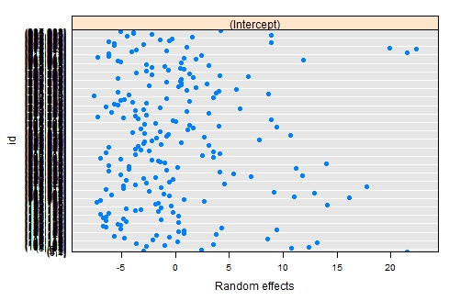
## Making the Normal Q-Q Plot to see if there is normal distribution for the individual means (Residuals).
> par(mfrow=c(1,2), cex=1.5)
> plot(residuals(mixmodel, type="pearson") ~ predict(mixmodel))
> abline(h=0, lty=3)
> lines(lowess(x=predict(mixmodel), y=resid(mixmodel, type="pearson")), col="red")
> qqnorm(residuals(mixmodel, type="pearson"))
> qqline(residuals(mixmodel, type="pearson"))
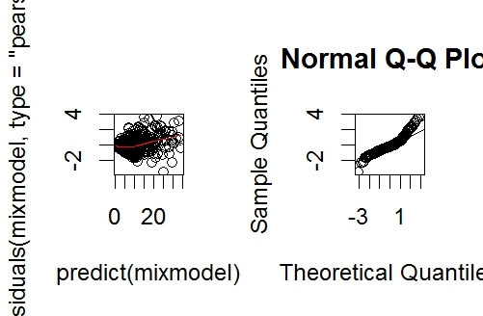
## Calculate ICC using the numbers in green below.
> summary(mixmodel)
Linear mixed-effects model fit by REML
Data: anxietylongreset
AIC BIC logLik
3812.625 3834.157 -1901.313

Random effects:
Formula: ~1 | id
(Intercept) Residual
StdDev: 6.750332 5.729195

Fixed effects: anxiety ~ time
Value Std.Error DF t-value p-value
(Intercept) 11.694444 0.6024282 333 19.412180 0
time2nd -3.545332 0.5882570 333 -6.026843 0
time3rd -3.568249 0.6293873 333 -5.669401 0
Correlation:
(Intr) tim2nd
time2nd -0.429
time3rd -0.401 0.443

Standardized Within-Group Residuals:
Min Q1 Med Q3 Max
-3.4687975 -0.4814763 -0.1363871 0.3446362 3.7827155

Number of Observations: 551
Number of Groups: 216

##ICC: (6.750332)^2 / (6.750332)^2 + (5.729195)^2
##ICC: 0.5812807
## Proportion of total variation between mothers.
## Question #3.
> intervals(mixmodel)
Approximate 95% confidence intervals

Fixed effects:
lower est. upper
(Intercept) 10.509400 11.694444 12.879489
time2nd -4.702501 -3.545332 -2.388164
time3rd -4.806325 -3.568249 -2.330173
attr(,"label")
[1] "Fixed effects:"

Random Effects:
Level: id
lower est. upper
sd((Intercept)) 5.961013 6.750332 7.644168

Within-group standard error:
lower est. upper
5.312753 5.729195 6.178280
## Intercept is positive, meaning that there is an increase in anxiety for individuals given the independent variables included in the model.
##Intercept is nowhere near zero and the confidence intervals are also do not contain zero, which means that the difference between variances is statistically significant at the p <0.05 level.
## Add malignancy into the model for question 3b.
> mixmodel2 <- lme(anxiety ~ time + cancer, data=anxietylongreset, random=~1|id)
> summary(mixmodel2)
Linear mixed-effects model fit by REML
Data: anxietylongreset
AIC BIC logLik
3742.577 3768.304 -1865.288

Random effects:
Formula: ~1 | id
(Intercept) Residual
StdDev: 6.748217 5.698216

Fixed effects: anxiety ~ time + cancer
Value Std.Error DF t-value p-value
(Intercept) 9.548133 1.2250260 332 7.794229 0.0000
time2nd -3.512998 0.5885160 332 -5.969248 0.0000
time3rd -3.566740 0.6281376 332 -5.678277 0.0000
cancerYes 2.783062 1.3294038 206 2.093466 0.0375
Correlation:
(Intr) tim2nd tim3rd
time2nd -0.207
time3rd -0.206 0.447
cancerYes -0.866 -0.011 0.004

Standardized Within-Group Residuals:
Min Q1 Med Q3 Max
-3.5120761 -0.4783503 -0.1338862 0.3398523 3.7731861

Number of Observations: 542
Number of Groups: 208

> intervals(mixmodel2)
Approximate 95% confidence intervals

Fixed effects:
lower est. upper
(Intercept) 7.1383416 9.548133 11.957925
time2nd -4.6706888 -3.512998 -2.355308
time3rd -4.8023711 -3.566740 -2.331108
cancerYes 0.1620803 2.783062 5.404043
attr(,"label")
[1] "Fixed effects:"

Random Effects:
Level: id
lower est. upper
sd((Intercept)) 5.946948 6.748217 7.657446

Within-group standard error:
lower est. upper
5.281953 5.698216 6.147285

## Adding time into the random effect.
## Close R and restart R. Convert ID into categorical. Repeat everything abov##e before running “mixmodel” Do not convert time into categorical. Leave tim##e continuous.
> mixmodel3 <- lme(anxiety ~ time, data=anxietylongreset, random=~time|id, na.action=na.omit)

> summary(mixmodel3)
Linear mixed-effects model fit by REML
Data: anxietylongreset
AIC BIC logLik
3752.014 3777.764 -1870.007

Random effects:
Formula: ~time | id
Structure: General positive-definite, Log-Cholesky parametrization
StdDev Corr
(Intercept) 9.425403 (Intr)
time 2.792382 -0.685
Residual 5.079775

Fixed effects: anxiety ~ time
Value Std.Error DF t-value p-value
(Intercept) 13.287528 0.8663399 333 15.33755 0
time -1.971096 0.3471212 333 -5.67841 0
Correlation:
(Intr)
time -0.786

Standardized Within-Group Residuals:
Min Q1 Med Q3 Max
-2.97484063 -0.42484952 -0.09971079 0.29550039 3.95325574

Number of Observations: 542
Number of Groups: 208

> intervals(mixmodel3)
Approximate 95% confidence intervals

Fixed effects:
lower est. upper
(Intercept) 11.583339 13.287528 14.99172
time -2.653923 -1.971096 -1.28827
attr(,"label")
[1] "Fixed effects:"

Random Effects:
Level: id
lower est. upper
sd((Intercept)) 7.8331257 9.4254028 11.3413498
sd(time) 1.9730117 2.7923823 3.9520288
cor((Intercept),time) -0.8100394 -0.6850355 -0.5004739

Within-group standard error:
lower est. upper
4.564888 5.079775 5.652737

## Using Time*cancer (interaction).

> mixmodel4 <- lme(anxiety ~ time*cancer, data=anxietylongreset, random=~time|id, na.action=na.omit)
> summary(mixmodel4)
Linear mixed-effects model fit by REML
Data: anxietylongreset
AIC BIC logLik
3746.552 3780.855 -1865.276

Random effects:
Formula: ~time | id
Structure: General positive-definite, Log-Cholesky parametrization
StdDev Corr
(Intercept) 9.460254 (Intr)
time 2.801113 -0.7
Residual 5.080944

Fixed effects: anxiety ~ time * cancer
Value Std.Error DF t-value p-value
(Intercept) 12.354417 1.9268552 332 6.411700 0.0000
time -2.646124 0.7655042 332 -3.456707 0.0006
cancerYes 1.156483 2.1583074 206 0.535829 0.5927
time:cancerYes 0.850169 0.8589233 332 0.989807 0.3230
Correlation:
(Intr) time cncrYs
time -0.790
cancerYes -0.893 0.705
time:cancerYes 0.704 -0.891 -0.790

Standardized Within-Group Residuals:
Min Q1 Med Q3 Max
-2.9625233 -0.4303656 -0.1079389 0.3150975 3.9552983

Number of Observations: 542
Number of Groups: 208
> intervals(mixmodel4)
Approximate 95% confidence intervals

Fixed effects:
lower est. upper
(Intercept) 8.5640325 12.3544168 16.144801
time -4.1519739 -2.6461238 -1.140274
cancerYes -3.0987205 1.1564833 5.411687
time:cancerYes -0.8394496 0.8501686 2.539787
attr(,"label")
[1] "Fixed effects:"

Random Effects:
Level: id
lower est. upper
sd((Intercept)) 7.8607531 9.4602539 11.3852200
sd(time) 1.9783751 2.8011131 3.9659994
cor((Intercept),time) -0.8192784 -0.6996491 -0.5216523

Within-group standard error:
lower est. upper
4.565601 5.080944 5.654456
##Histogram for anxiety score frequency.
> hist(anxietylongreset$anxiety, col="orange", main="", xlab="Anxiety Score", ylab="Frequency", breaks=10)
##Bar graph for Malignancy Status.
> counts <- table(anxietylongreset$cancer)
> barplot(counts, xlab="Number of Mothers Whose Children have Cancer", col=c("darkblue","red"))

